SPHE POLICY

- Introduction Statement and Rationale

- Introductory Statement

The staff of Ballyleague N.S. formulated this school plan, in consultation with our Board of Management and our Parents.

- Rationale

Social, personal and health education (SPHE) provides particular opportunities to foster the personal development, health and will-being of each individual child, to help him/her to create and maintain supportive relationships and become an active and responsible citizen in society. Through our SPHE programme we aim to ensure that children can develop a framework of values, attitudes, understanding and skills that will inform their decisions and actions both now and in the future.

- Visions and Aims

- Vision

In Ballyleague N.S., we acknowledge the importance of SPHE in the life of the school and in light of keeping our children safe and happy. We feel that a positive happy school atmosphere fosters the health and well-being of all members of the school community and is crucial for learning. The learning and teaching climate that prevails in the classroom, the methodologies and approaches used and the relationships and the children experience and witness in the school, all contribute to their social, personal and health development.

SPHE in our school should
- Nurture feelings of self-worth and self-confidence in our pupils.
- Increase children’s awareness of themselves and others to enable them to live enjoyable, fulfilling and purposeful lives.
- Promote respectful, considerate behaviour towards others thus enabling children to create and main healthy friendships and relationships with the people around them.
- Ensure positive health messages are planned, modelled, implemented and reinforced on a continuous basis to enable children to develop a personal responsibility for their own health and make good decisions now and in the future.
- Encourage children to become responsible and active global citizens with a pride in their community and a caring attitude towards the world as a whole.
- Clarify as much as possible any misinformation which the children may receive and enable them to become more discerning in their appraisal of the media.

- Aims:

The children of Ballyleague N.S. should be enabled to achieve the aims outlined in the SPHE curriculum, which include:

- To promote the personal development and well-being of the child
- To foster in the child a sense of care and respect for himself/herself and others and an appreciation of the dignity of every human being
- To promote the health of the child and provide a foundation for healthy living in all its aspects
- To enable the child to make informed decisions and choices about the social, personal and health dimensions of life both now and in the future
- To develop in the child a sense of social responsibility, a commitment to active and participative citizenship and an appreciation of the democratic way of life
- To enable the child to respect human and cultural diversity and to appreciate and understand the interdependent nature of the world.

- Broad Objectives

When due account is taken of intrinsic abilities and varying circumstances, the SPHE curriculum should enable the child to:
- Be self-confident and have a positive sense of self-esteem
- Develop a sense of personal responsibility and come to understand his/her sexuality and the process of growth, development and reproduction
- Develop and enhance the social skills of communication, co-operation and conflict resolution
- Create and maintain supportive relationships both now and in the future
- Develop an understanding of healthy living, an ability to implement healthy behaviour and a willingness to participate in activities that promote and sustain health
- Develop a sense of safety and an ability to protect himself/herself from danger and abuse
- Make decisions, solve problems and take appropriate actions in various personal, social and health contexts
- Become aware of, and discerning about, the various influences on choices and decisions
- Begin to identify, review and evaluate the values and attitudes that are held by individuals and society and to recognise that these affect thoughts and actions
- Respect the environment and develop a sense of responsibility for its long-term care
- Develop some of the skills and abilities necessary for participating fully in groups and in society
- Become aware of some of the individual and community rights and responsibilities that come from living in a democracy
- Begin to understand the concepts of personal, local, national, European and global identity
- Appreciate and respect the diversity that exists in society and the positive contributions of various cultural, religious and social groups
- Promote the values of a just and caring society in an age-appropriate manner and understand the importance of seeking truth and peace.

- Content of Plan

Curriculum:

- Strands and Strand Units:

The SPHE curriculum is delineated at four levels:

- Infant Classes
- First & Second Classes
- Third & Fourth Classes
- Fifth &Sixth Classes

and is divided into three strands:

Strands of the SPHE Curriculum
Myself | Myself and Others | Myself and the  Wider World

Each of these strands is further subdivided into a number of strand units or topic areas that contain particular objectives.

Ballyleague N.S. will teach aspects of all three strands units each year and strand units will be chosen in such a way that the child will receive a comprehensive programme in SPHE over a two year period. Ballyleague N.S. has created the timetable outlined as follows to reflect this approach. Particular topics may also be addressed incidentally during the year if the need arises (e.g. anti-bullying, etc.)

SPHE – 2 Year Cycle
Time of Year | Year 1  Strand and Strand Unit  2018/2019, 2020/2021, 2022/2023 | Year 2  Strand and Strand Unit  2019/2020, 2021/2022, 2023/2024
September – October | Self-identity  - Self-awareness  - Developing self-confidence  - Making decisions  - Classroom Rules | My Friends and other people  - Friendship and Bullying  - Treating others and dignity and respect  - Peer pressure  - Classroom Rules
November – December | Myself and My Family  - My family  - Different types of families  - How families look after each other  - Communication  - Changes that happen in families  - Family life in other countries | Relating to others  - Making friends/meeting people  - Manners  - Empathy and understanding  - Listening to each other  - Expressing opinions  - Compliments  - Conflict resolution
January – February | Safety and Protection  - Stay Safe  - Feeling Safe and Unsafe  - Friendship and Bullying  - Touches  - Secrets and Telling  - Strangers | Growing and Changing  - Feelings and Emotions  - As I grow I change  - New Life  - Sensitive areas of RSE 2nd  Making Decisions 3rd – 6th  - Sensitive areas of RSE 3rd – 6th  - Rights and responsibilities
March – April | Taking Care of My Body  - Knowing about my body  - Food and Nutrition  - Health and Wellbeing | Safety and Protection  - Personal Safety  - Safety Issues  - Farm Safety, Water Safety, etc.  - Drugs and Alcohol  - Medicines  - The consequences of risky behaviour
May – June | Developing Citizenship  - My school community  - Living in the local community  - Environmental care  - Local and wider communities (4th/5th)  - National, European and wider communities (5th/6th) | Media Education  - Distinguish between fact and fiction  - Cyber Safety – Webwise  - The power of advertising – Mediawise  - Cyber bullying – Myselfie and the wider world

- Teaching Resources:

In Ballyleague N.S. we use the following DES resources to support the teaching of SPHE.

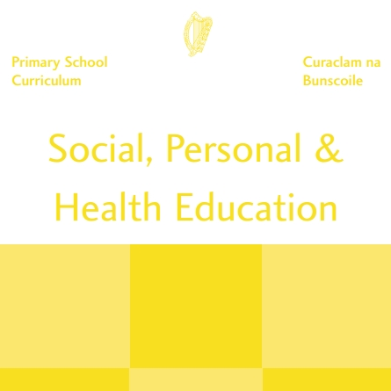 | 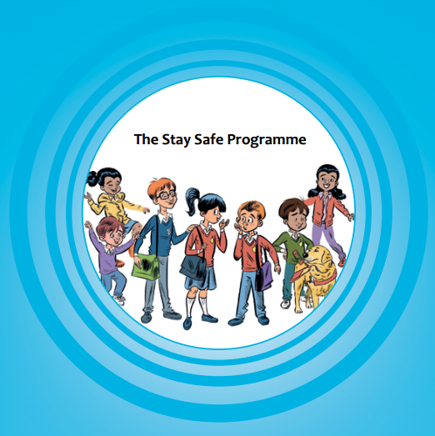 | 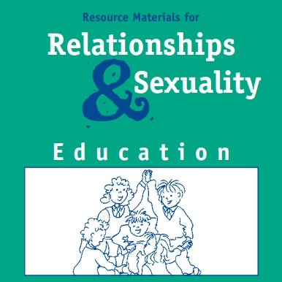 | 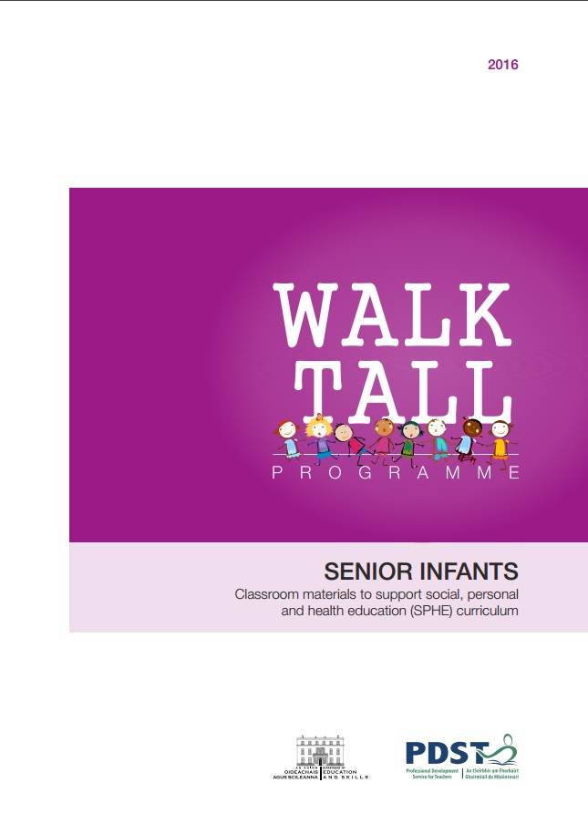
SPHE Curriculum and Teacher Guidelines | Revised Stay Safe Programme | Relationships and Sexuality Education | Revised Walk Tall Programme

Teachers can use the Making the Links booklet to assist them with planning.

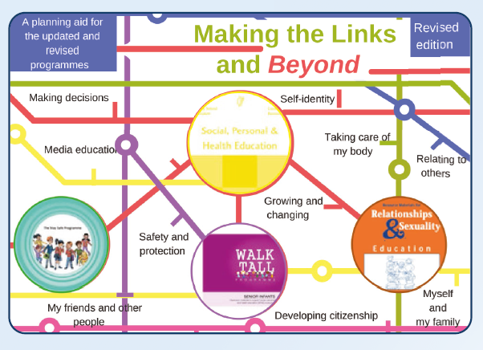

The following programmes are also used in Ballyleague N.S. to address objectives of the SPHE curriculum

Aistear
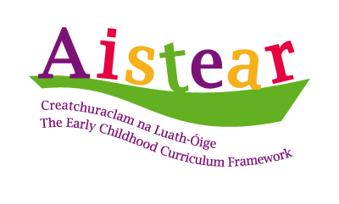
Infant teachers can use the Aistear Framework to enable children to meet some of the objectives of SPHE. The Aistear Framework uses interconnected themes to describe the content of children’s learning and development: Well-being, identity and Belonging, Communicating, and Exploring and Thinking. Aistear highlights the critical role of play, relationships and language for young children’s learning. In these early years children learn through loving, trusting and respectful relationships, and through discussion, exploration and play. They learn about languages and how and when to use them; they learn to think and to interact with others and environment. They learn to be creative and adventurous, to develop working theories about their world, and to make decisions about themselves as learners.

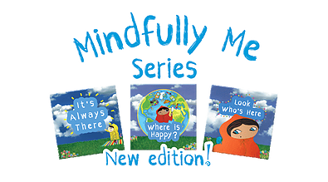
Mindfully Me
“Mindfully Me” by Louise Shanagher and Rose Finerty, supports the SPHE curriculum and the Aistear framework and links particularly well with the Strand “Myself” and the Strand Units of Self Identity, Growing and Changing. “Mindfully Me” encourages children to relate positively to their feelings, to have a compassionate attitude towards themselves, to express and understand their emotions, through mindful practice.
Restorative Practice
Restorative practice is a child centred programme focused on restorative language, restorative circles, restorative questioning, which allows children to become central to the resolution of problems and re-setting of goals to minimise conflict, develop self- awareness, improve the quality of their relationships in school. Our teachers have participated in Restorative Practice training with PDST and this programme is being implemented in our school.

NOTE - re: The Stay Safe Programme
The Stay Safe Programme is a personal safety skills programme for primary schools taught in the context of social, personal and health education. The aim of the programme is to reduce vulnerability to child abuse and bullying through the provision of personal safety education for children. It is developmentally structured to enable primary school teachers to deliver an abuse prevention education that addresses personal safety issues such as physical, emotional and sexual abuse as well as bullying and stranger danger. The importance of building confidence and self-esteem and developing assertiveness and strong clear communication is emphasised throughout the programme. Children are taught that it is not their fault if they are bullied or abused.

In the Stay Safe programme, children learn the following:
- About Feelings: To recognise the importance of feelings; how to express them appropriately and in particular to recognise unsafe feelings
- About Friendship: Making and keeping friends and the value of friendship
- About Bullying: What bullying is; strategies for dealing with bullying behaviour, and that it is never acceptable to bully others
- The importance of building confidence and self esteem
- How to identify and deal with inappropriate or unsafe touch
- That it is OK to say ‘no’ to an adult in a situation where they feel unsafe, threatened or frightened
- To identify trusted adults who they should tell if they are feeling frightened, threatened, worried or unsafe in any way
- To understand how someone might bribe, trick or threaten them to keep a secret
- It is never their fault if they are victimised or abused
- That they should never go anywhere with or take anything from a stranger
- Appropriate language for telling
- The Stay Safe rules: Say No, Get Away and Tell, Never keep secrets about touch, never go anywhere with or take anything from a stranger.

All primary schools are required to fully implement the Stay Safe Programme (DES circular 65/2011) within the context of the SPHE curriculum. The programme should be taught once as part of each two-year cycle of SPHE. The programme should be taught in its entirety over one school year. Each topic builds on the learning from the previous topic, therefore teachers should ensure that the topics are taught consecutively, beginning with Topic 1 and working through to Topic 5. Teachers in Ballyleague N.S. will endeavour to work through the programme in one block as recommended in the Stay Safe Teacher’s Guide (p.7).

Stay Safe  Topic | Number of Lessons
Stay Safe  Topic | Junior & Senior Infants | 1st & 2nd | 3rd & 4th | 5th & 6th
Feeling Safe and Unsafe | 3 | 3 | 3 | 3
Friendship and Bullying | 3 | 5 | 6 | 6
Touches | 2 | 2 | 2 | 2
Secrets and Telling | 1 | 1 | 1 | 1
Strangers | 1 | 1 | 1 | 1

Parental Participation in the Stay Safe Programme
In Ballyleague N.S. we recognise that partnership with parents is an essential component in the promotion and building of key life skills. Research has shown that parental involvement in abuse prevention programmes is directly related to increased programme success. This is due to the increased communication between the parent/carer and child about sensitive issues and abuse. Parental involvement gives children more opportunities to repeat the concepts and messages learned. Parental participation is an essential part of the Stay Safe Programme both in terms of reinforcement and follow-up.

In Ballyleague N.S. we will use the home school links (HSL) on each topic that are included throughout the programme. These HSL will inform parents/carers on the topics and specific lessons being covered in class and how they can reinforce the messages at home.

Parents have the right to have their child/children opt out of any of the sensitive aspects of the Stay Safe Programme if they so wish. Therefore, we will inform parents/carers that Stay Safe is being implemented in the school. This is normally done in schools as part of the enrolment process. Parents should be invited to contact the school if they have any queries or concerns about their child’s participation in the programme. We will engage with parents in relation to any concerns or queries they may have. It is not necessary to get parental consent in writing before teaching Stay Safe. However in the event that a parent withdraws their child from participation in the programme, in line with advice presented in the Teacher Guidelines of the Stay Safe Programme, we will keep a written record of their reasons for so doing. In the case of a child being withdrawn from any element of SPHE, parents will take full responsibility for teaching those concepts to their children. We will also advise parents/carers in advance of commencement of lessons by way of a text or note. Parents can familiarise themselves with the content of all Stay Safe lessons at www.pdst.ie/staysafe

In the Stay Safe Programme, children are encouraged to use appropriate language for telling, including the correct anatomical terms for parts of the body. This is in line with SPHE Curriculum Guidelines (page 11).

A note on Language

There is a great deal of power in language and not being familiar with the biological terms for the body can put children at a disadvantage. To give children this vocabulary, it is recommended that the teacher uses everyday situations to include word for the body, and bodily functions, naturally and without undue emphasis. The teaching materials for Relationships and Sexuality Education (a core element of SPHE) are designed to give teachers a variety of opportunities to introduce terminology for body parts in the context of hygiene practice, illness, injury, swimming etc. In the RSE Booklet for Parents, Going Forward Together, the following rationale is given for the use of correct terminology for body parts:

It is important that children learn the appropriate vocabulary for discussing aspects of life related to sexuality, growing up and their body’s physical changes so that they can communicate confidently about themselves. When children begin school, it is not unusual, indeed it is quite normal, for them to have other names for their genitals. However, the use of proper terms for parts of the body and bodily functions should be encouraged from the earliest age, sot that these terms are given a status and an acceptability. As children get older and become comfortable with these words, they can discuss aspects of their growth and development with greater ease. They are also less likely to resort to inappropriate or vulgar language when referring to the body or bodily functions.

In addition, the SPHE Curriculum Guidelines (page 11) state:

As physical growth and development are explored, children learn the appropriate anatomical terms for the private parts of both the male and female body. Acquiring this vocabulary at an early age provides the foundation for later learning on puberty and reproduction and can help children to speak about all parts of their bodies in a respectful and dignified way. Children can acquire the language and vocabulary necessary to discuss his/her own growth and development as well as being able to ask appropriate questions and clarify and find information that he/she might need.

Appendix 1 of this policy indicated the biological terms for the body which are to be used and the ages at which they will be introduced, in line with the SPHE curriculum. Using the correct anatomical terminology is an important feature of the Stay Safe and RSE Programmes.

Guest Speakers

When a guest speaker addresses the children in any are of SPHE, the class teacher must remain in the classroom and ensure the speaker is aware of this school plan and attached policies (see circular 22/2010).

Contexts for SPHE

SPHE will be taught in Ballyleague N.S. through a combination of the following three contexts:

- Positive School Climate and Atmosphere

Ballyleague N.S. has created a positive atmosphere by:
- Building effective communication
- Catering for individual needs
- Creating a health-promoting physical environment
- Developing democratic processes
- Enhancing self-esteem
- Fostering respect for diversity
- Fostering inclusive and respectful language
- Developing appropriate communication
- Developing a school approach to assessment

The SPHE guidelines on pages 22-28 address each of the strategies in detail, and further suggestions are outlined on pages 22 and 42 of the Anti-Bullying Procedures.

We operate a Positive Rewards System in our school whereby children are rewarded in a variety of ways for displaying positive behaviour including good manners, respectful communication, inclusive practices in the yard, effort and diligence in their school work, kindness etc.

- Discrete time for SPHE

SPHE is allocated ½ hour per week on each teacher’s timetable in Ballyleague N.S. However, in our overall planning, time should relate to the way in which the chosen objectives of the curriculum are being achieved, rather that the number of hours spent. For example, it may be more appropriate on occasions to use the discrete time in block periods rather than as a series of half-hour slots, such as allocating one hour per fortnight to allow for more indepth exploration of a strand unit. Teachers may also allocate discretionary curricular time to SPHE. Additional time allocated to SPHE will provide a space for teachers to deal with sensitive issues or to explore issues as they arise. This flexibility can be explored among the teachers and decisions made according to individual or school needs, particularly in relation to the delivery of the Stay Safe programme.

- Integration with other subject areas and Linkage within SPHE

Teachers will endeavour to adopt an thematic approach to SPHE by integrating it with other subject areas such as Language, Science, Geography, History, Religion, Music, Drama, Visual Arts, Physical Education, etc. Themes/Projects such as Healthy Eating Week, Agri-Awareness, Active School Week, Lenten Campaign, Environmental Care can also be explored through SPHE. This is a particularly useful way of highlighting an aspect of the curriculum and ensuring a consistent approach throughout the school. Through an integrated approach, teachers will gain greater flexibility when timetabling for discrete time. Suggested approaches for integration are outlined in Section 4 of the SPHE Teacher Guidelines.

Teaching Approaches and Methodologies

Ballyleague N.S. believe that the approaches and methodologies used in SPHE are crucial to the effectiveness of the programme. Active learning is the principal learning and teaching approach recommended for SPHE, therefore we will endeavour to teach SPHE using a variety of strategies which include:

- Drama activities
- Talk and discussion (including circle time)
- Co-operative games
- Use of picture, photographs and visual images
- Written activities
- Use of media and information technologies
- Using the natural environment.

The emphasis at all times will be on building a foundation of skills, values, attitudes and understanding. The SPHE programme will be spiral in nature in so far as the children’s skills and abilities will be consolidated, expanded and augmented in every subject area and at every level as they progress through the school.

Assessment

Assessment is a central part of the everyday learning and teaching process in SPHE. It can provide valuable information of the child’s progress and on the effectiveness and suitability of the programme and the teaching methods being used. Ballyleague N.S. uses the following recommended informal tools for assessment in SPHE: Teacher Observation and Teacher-designed Tasks and Project Work. Assessment information is shared as required at Parent Teacher meetings and in end-of-year reports.

Teacher observation might focus on:
- The ability of the child to co-operate and work in groups or to work independently
- The informal interactions between the child and adults and between the child and other children
- The quality of presentation of work
- Particular interests or aptitudes displayed by the child
- The participation and interest of the child in a variety of activities
- The level of personal or social responsibility exhibited by the child
- The reliability of the child in carrying out established routines
- The perseverance of the child in carrying out a task
- The child’s awareness of the difficulties of others and his/her willingness to help
- The questions the child asks and the responses the child makes to question and suggestions made by the teacher
- Various behaviour, for example shyness, leadership ability, level of self-confidence, the tendency to be anxious, sense of fair play, assertiveness, aggression, readiness to take risks and meet challenges
- Physical and emotional maturity
- The ability of the child to engage in assessing his/her progress and reflecting on his/her learning
(SPHE Curriculum, page 73)

Teacher designed tasks help the teacher evaluate if the child understands what is being taught and if they are able to transfer/use what they are learning in a variety of situations.

Project Work is a useful assessment tool which may be used to monitor the child’s ability to work in a group, to assess leadership skills and to view presentation, creative skills.

Homework:
SPHE homework, if prescribed in SPHE, will reflect the active learning approach and will reinforce information already taught during class.

Children with Different Needs:
SPHE addresses areas that are particularly important for students with special educational needs. The development of positive self-esteem, social and communication skills, appropriate expression of feelings, and safety and protection skills are particularly important, as many students with general learning disabilities lack confidence. These students need opportunities to develop these skills through a structured programme. By providing opportunities within the curriculum these students can be helped to become more confident and to relate to others by learning effective means of handling situations. Teachers will endeavour to adapt and modify activities and methodologies in SPHE to encourage participation by children with special educational needs. The requirements of children with special educational needs will be taken into consideration when planning lessons in sensitive areas such as RSE and Child Protection. The special education teacher will supplement the work of the class teachers where necessary.

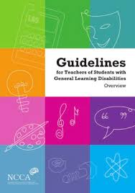
Teachers will utilise the NCCA Guidelines for SPHE for Teachers of Children with GLD to inform planning and preparation of teaching children with Special Educational Needs. These guidelines are available to download from www.ncca.ie

Ballyleague N.S. will liaise with trained professionals and appropriate agencies such as NEPS and SESS when dealing with sensitive issues such as bereavement, loss, illness or major life incidents to ensure that the children involved are fully supported.

Equality of Participation and Access

Ballyleague N.S. recognises and values diversity, and believes all children are entitled to access the services, facilities or amenities that are available in the school environment. Ours is mixed co-educational school in a rural village. We endeavour to challenge traditional stereotypes and ensure that equal opportunities are given to boys and girls. Children live in a diverse society, and this diversity requires the development of mutual understanding and a sense of respect for the dignity of every human being. Our SPHE programme provides a context in which children can learn about various ethnic, social and cultural groups and can recognise and appreciate the contributions of these groups to society. As they acquire a deeper understanding of their own traditions and heritage, they are encouraged to act in ways that foster inclusiveness and to have regard for the heritage and perspectives of others. Through SPHE children can discover the role each person has to play in counteracting prejudice, discrimination and inequality as they may experience it in their own lives. All children will be offered equal access to the SPHE programme.

Education not only reflects society but also influences its development. As such, schools have a role to play in the development of an intercultural society. While education cannot bear the sole responsibility for challenging racism and promoting intercultural competence, it has an important contribution to make in facilitating the development of the child’s intercultural skills, attitudes, values and knowledge. An intercultural education is valuable to all children in equipping them to participate in an increasingly adverse society.
Intercultural Education in the Primary School – NCCA
http://www.ncca.ie/uploadedfiles/publications/interculrtural.pdf

Community Links:

Ballyleague N.S. believe that the local community has a very important role to play in supporting the programme in SPHE and endeavour to liaise with the members such as the Dental Hygienist, Health Nurse, Fire Department, Vet, New Parent, etc.

Individual Teachers’ Planning and Reporting

This plan SPHE and the SPHE curriculum documents will inform and guide teachers in their long and short term planning in SPHE. Each teacher will keep a Cuntas Míosúil and this will inform our progress and needs when evaluating and reviewing our progress in SPHE.
Staff Development

The staff will be encouraged to attend training in the following areas and this training will support an effective implementation of the SPHE programme:
- Training in the revised Stay Safe Programme (PDST)
- Training in the revised Walk Tall Programme (PDST)
- Training in the Relationships and Sexuality Education (RSE) Programme (PDST)
- PDST SPHE support
- Training in Children First Guidelines and Child Protection Procedures for DLP and DDLP
- Training in Anti-Bullying (PDST)
- SPHE Summer Courses
Teachers are encouraged to attend SPHE related courses and will share information/skills acquired at these courses with other members of staff during staff meetings.

We will request the support of the Professional Development Service for Teachers if required at http://dmsnew.pdst.ie/school/register

Policies that Support SPHE

- Anti-Bullying Policy
- Child Protection Policy
- Relationships and Sexuality Education Policy
- Code of Behaviour
- Enrolment Policy
- Health & Safety Policy
- Healthy Eating Policy
- Substance Use Policy (including Administration of Medicines)
- Internet Safety Policy
- Supervision Policy

Circulars related to SPHE

- 22/2010 – SPHE Best Practice for Primary Schools
- 65/2011 – Child Protection Procedures for Primary Schools
- 45/2013 – Anti-Bullying Procedures for Primary Schools
- 13/2016 - Promotion of Healthy Lifestyles in Primary Schools
- 81/2017 - New Child Protection Procedures for Primary Schools

- Success Criteria

The success of this plan will be evaluated through teacher’s planning and preparation, and if the procedures outlines in this plan have been consistently followed. We will also judge its success if the children have been enabled to achieve the aims outlines in this plan.

- Implementation

- Roles and Responsibilities

Ballyleague N.S. believes that the school community must be involved to successfully implement SPHE. Therefore the teaching staff will implement this plan with the support of the Board of Management, Parents and the Local Community.

- Review

(a) Roles and Responsibilities

It will be necessary to review this plan on a regular basis to ensure optimum implementation of the SPHE curriculum in the school.

Those involved in the review may include:

- Teachers
- Pupils
- Parents
- Post Holders / Plan Co-ordinator
- BOM/DES/PDST/Others

- Ratification and Communication

This plan is available to view at the school by the parents on request.

